IC-16B: ROTATIONAL INERTIA – disk, ring, point masses (Rotary Motion Sensor)

Rev 10-30-2023

16.1 OBJECTIVE
To find the moments of inertia for a disk, ring (thick shell cylinder), and point masses, and compare with theoretical values.
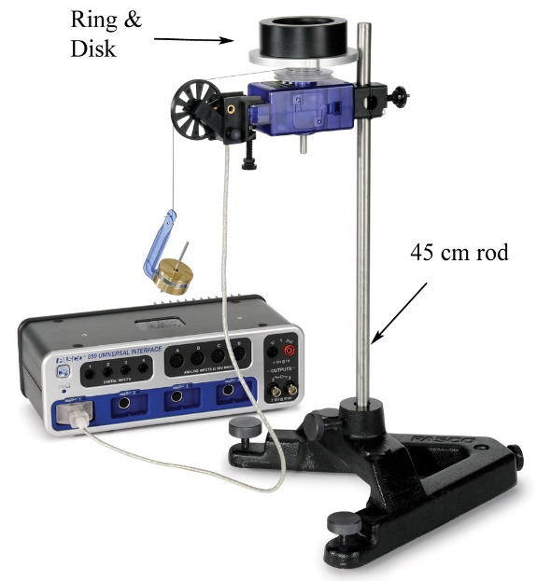
Figure 1: Measuring the Rotational Inertia of Ring and Disk

16.2 EQUIPMENT
Rotary Motion Sensor (PS-2120A)
Large Rod Base (ME-8735)
Rotational Accessory (CI-6691)
Vernier Calipers (SE-8710)
Clamp-on Pulley (in CI-6691)
Balance (SE-8723)
Thread (in CI-6691)
45 cm Rod (ME-8736)
Mass and Hanger Set (ME-8979)

16.3 THEORY
The rotational inertia of an object is a measure of how hard it is to rotate the object. The purpose of this experiment is to find the rotational inertia of a ring and a disk experimentally, and to verify that these values correspond to the calculated theoretical values.
Theoretically, the rotational inertia, I, of a thick ring about an axis passing through the center is given by
R₂
R₁
RING
DISC
R_{D}
I = ½ M_{R} (R₁² + R₂²) (1)
where M_{R} is the mass of the ring, R₁ is the inner radius of the ring, and R₂ is the outer radius of the ring, as shown in Figure 2. The rotational inertia of a disk is given by
I = ½ M_{D} R_{D}² (2)
where M_{D} is the mass of the disk and R_{D} is the radius of the disk.
Figure 2: Rotation Axis for Ring and Disk

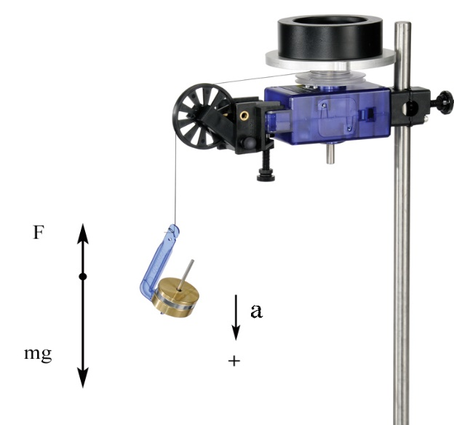
To find the rotational inertia of the ring and disk experimentally, a known torque is applied to the ring and disk, and the resulting angular acceleration, α, is measured. See Fig. 3.
Figure 3: Free-Body Diagram
τ = I α (3)
where τ is the torque caused by the weight hanging from the thread wrapped around the three-step pulley of radius, r.
τ = r F (4)
The tension in the string, F, is less than the weight, due to the downward acceleration. Applying Newton's Second Law for the hanging mass, m, (see Figure 5) yields
F = m ( g – a ) (5)
Finally, the linear acceleration, a, is related to the angular acceleration, α, by
a = r α (6)
A known torque is applied to the three-step pulley on the Rotary Motion Sensor, causing a disk and ring to rotate. The resulting angular acceleration is measured using the slope of a graph of angular velocity versus time. The rotational inertia of the disk and ring combination is calculated from the torque and the angular acceleration. The procedure is repeated for the disk alone to find the rotational inertias of the ring and disk separately.

16.4 EQUIPMENT SETUP
1. Use the large rod base and the 45 cm rod to support the Rotary Motion Sensor as shown in Figure 1. Plug the sensor into the interface.
2. Use calipers to measure the radius (r) of the medium size pulley on the clear three-step pulley.
3. Cut a piece of thread about 75 cm long. Run the thread through the hole in the medium size pulley as shown in Figure 4. Tie a large knot inside the pulley to keep the thread from pulling though.
4. Clamp the black pulley onto the Rotary Motion Sensor as shown in Figure 5. Note how the pulley is clamped at an angle to match the tangent to the clear three-step pulley. It must also be adjusted vertically using the two thumbscrews, to match the height of the clear pulley being used.
5. Connect a mass hanger to the end of the thread. Adjust the length so that it doesn't quite hit the table.
6. When you wind up the thread onto the three-step pulley, make sure the thread winds smoothly with no overlaps. Also, do not place too much thread on the pulley: You only want a single layer of thread, so that the radius stays constant.
7. In PASCO Capstone, create a graph of Angular Velocity vs. Time. Set the sample rate to 20 Hz.
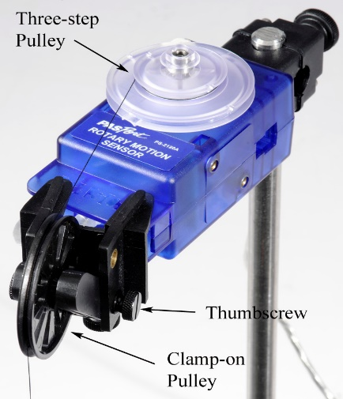
Figure 5: Adjusting Angle of Clamp-on Pulley

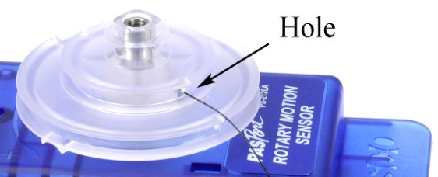
Figure 4: Attaching Thread to Pulley

16.5 PROCEDURE – RING AND DISK
1. Fasten the disk to the shaft of the Rotary Motion Sensor using the thumbscrew. Position the ring on top using the two pins to key it to the disk.
2. Hang about 50 g on the mass hanger, and let it fall. With the mass of the hanger, this is the Total Hanging Mass M_{TH}. The pulley will start spinning. Collect a run of angular velocity vs. time data. Record all values in table below.
3. Use a linear curve fit to find the angular acceleration (See figure 6 for an example)
4. Accounting for Friction: Put just enough mass on the thread to make it fall at a constant speed after you give it a starting push. It will only be about a gram so you won't be able to use the mass hanger. This is called the friction mass, M_{F}, and is subtracted from the Total Hanging Mass, M_{TH}, to obtain the hanging mass, m, to use in further calculations: m = M_{TH} – M_{F}.
5. Remove the ring, and repeat the above procedure for just the disk. Use about 15 g, and also find the friction mass.
6. Remove the disk and repeat for just the pulley. Use about 1 g, but don't bother with the friction mass, as it will be too small.

16.6 PROCEDURE – POINT MASSES
We will now find the rotational inertia of point masses. This will be done with two point masses attached to the black rod from the Rotation Accessory, once with the two masses close to the ends of the rod, and again with the two masses close to the center of the rod.
1. Using a meter stick, position the brass masses on the black rod as accurately as possible so that their centers of mass are at the same distance from the center of rotation. In the first case, keep the two masses as far apart as you can on the rod (Fig 7). Attach the black rod to the clear pulley (see Fig. 7).
2. Now repeat the procedure to find the Rotational Inertia as was done earlier for the disk.
3. Repeat the procedure with the two masses near the center of the rod (see Figure 8).
4. The moment of inertia for a point mass is: Σ MR².
5. Consider how you would account for the effect of the rod, and include it’s effect in your calculations.

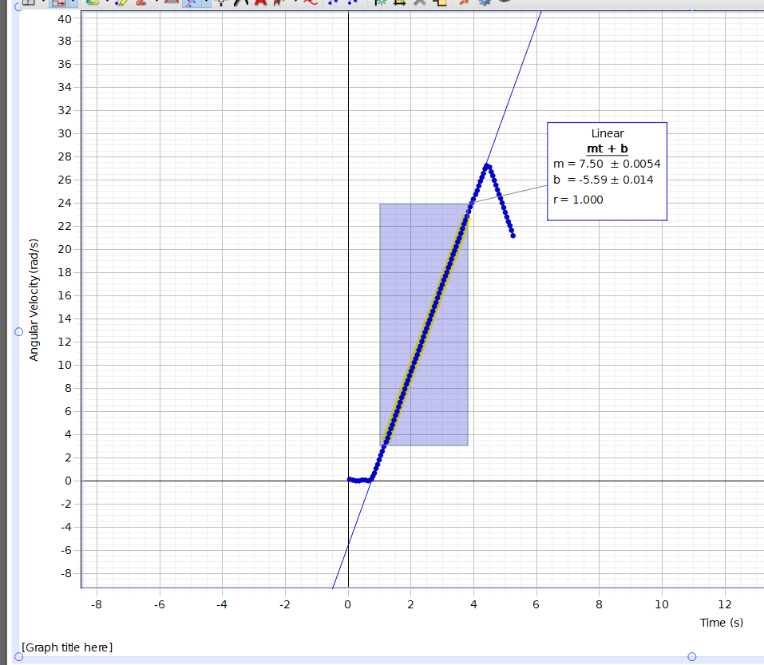
Figure 6:
Plot of angular velocity versus time

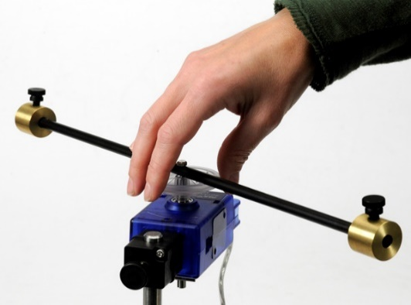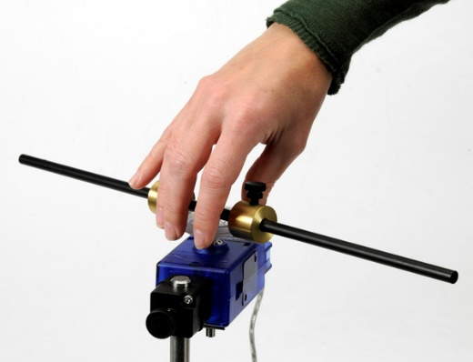
Figure 7: Masses at Far position

Figure 8: Masses at Near Position

CALCULATIONS
1. Use the measured value of the angular acceleration of the three step pulley, α, to get the linear acceleration of the hanging mass by using eqn. 6: a = r α
2. Use the values of total hanging mass M_{TH} and the friction mass M_{F}, get the hanging mass to use, m : m = M_{TH} — M_{F}
3. Calculate the tension F by using equation 5: F = m ( g – a )
4. Calculate the torque by using equation 4: τ = r F
5. Calculate the Moment of inertia by using equation 3: τ = I α

16.7 PRECAUTIONS:
1. Make sure the three-step pulley is horizontal.
2. Don’t force the three-step pulley in the shaft. When properly aligned, it will slide in easily.
3. Don’t use too much or too little hanging mass. We want an angular speed that is not too high or too small.
4. The hanging mass should not swing like a pendulum while it is going down.
5. Adjust the clamp-on pulley so that the string is horizontal, and also goes straight from the clamp-on pulley to the three step pulley (see Fig. 5)

16.8 IC-16 ROTATIONAL INERTIA REPORT FORM

DATA FOR RING AND DISK

Ring: mass M_{R}: _________ Inner radius, R₁: ________ Outer Radius, R₂: __________
Disk: mass M_{D}: _________ Radius, R: ________
Three-step pulley: mass: _________ Radius on which thread is wrapped, r: ________
Outer radius of 3-step pulley: _________

 | Symbol, units | Run # 1  Pulley+disk+ring | Run # 2  Pulley+disk | Run # 3  Pulley
Total Hanging Mass (including hanger) | M_{TH} g
Angular acceleration (from graph) | α rad/s²
Linear acceleration (eqn. 6) a = r α | a m/s²
Friction mass | M_{F} g
Hanging mass to use m = M_{TH} – M_{F} | m g
Tension in string (eqn. 5) F = m ( g – a ) | T N
Torque  (eqn. 4) τ = r F | τ N.m
Moment of inertia (eqn. 3) τ = I α | I kg.m²

MOMENTS OF INERTIA
 |  | Experimental | Theoretical | % error
I for Ring kg.m² | Run #1 – #2
I for disk kg.m² | Run #2 – #3
I for pulley kg.m² | Run #3

DATA FOR ROD AND POINT MASSES
Rod: mass: _________ Length: ________
Point masses: Mass-1: ________ Distance from center: Far: ________ Near: _________
Mass-2: ________ Distance from center: Far: ________ Near: _________
Radius of pulley used, r: ________

 | Symbol, units | Run # 1  Rod + masses  at Far position | Run # 2  Rod+ masses  at Near position | Run # 3  Rod alone
Total Hanging Mass | M_{TH} g
Angular acceleration (from graph) | α rad/s²
Linear acceleration (eqn. 6) a = r α | a m/s²
Friction mass | M_{F} g
Hanging mass to use  m = M_{TH} – M_{F} | m g
Tension in string  (eqn. 5) F = m ( g – a ) | T N
Torque  (eqn. 4) τ = r F | τ N.m
Moment of inertia (eqn. 3) τ = I α | I kg.m²

MOMENTS OF INERTIA
 |  | Experimental | Theoretical | % error
I for Rod kg.m² | Run #3
I for Masses kg.m²  (large radius) | Run #1 – #3
I for masses kg.m²  (small radius) | Run #2 – #3

16.9 CALCULATIONS
- Use the angular acceleration you measured for the ring & disk to calculate their combined rotational inertia. You will first need to calculate the applied torque using Equations (4) through (6). Remember to subtract the friction mass from your value for the hanging mass before doing the calculation.
- Use Equation (3) to calculate the rotational inertia of the (Ring + Disk + Pulley) combined.
- Repeat steps 1 and 2 above to calculate the rotational inertia for the (Disk & Pulley) combined.
- Repeat steps 1 and 2 above to calculate the rotational inertia for the Pulley only.
- Subtract the (Disk + Pulley) inertia from the (Ring + Disk + Pulley) inertia to calculate the rotational inertia of just the Ring.
- Subtract the (Pulley) inertia from the (Disk & Pulley) inertia to calculate the rotational inertia of just the Disk.
- Use Equations (1) and (2) to calculate the theoretical rotational inertias for the ring and disk.
- Compare to the measured inertia using a % error calculation.

16.10 REPORT SUBMISSION
Upload the following in the Report for this Lab:
 |  | Points in report
 | Report Form for Ring-Disk | 10
 | Results Ring-Disk | 5
 | Screenshot of at least one Capstone graph showing the angular speed versus time for Ring-Disk. | 5
 | Report Form Point Masses | 10
 | Results Point Masses | 5
 | Screenshot of at least one Capstone graph showing the angular speed versus time for Point masses | 5
 | Sources of Error in this experiment. Make a list of sources of error. | 5
 | Discussion of the Results of this experiment. Do not ignore major errors | 10
 | Total | 55

Keep “Sources of Error” as a separate heading, and “Discussion” as a separate heading.
Extra Credit: Uploading a short video will get you up to 5 points extra credit.

SAMPLE DATA

Ring and Disk (note: this is not actual data)
Ring: mass M_{R}: 400 g Inner radius, R₁: 2.50 cm Outer Radius, R₂: 3.10 cm
Disk: mass M_{D}: 100 g Radius, R: 5.00 cm
Three-step pulley: mass: 5.00 g Radius on which thread is wrapped, r: 1.30 cm
Outer radius of 3-step pulley: 5.15 cm

 | Symbol, units | Run # 1  Pulley + disk+ring | Run # 2  Pulley+disk | Run # 3  Pulley
Total Hanging Mass (including hanger) | M_{TH} g | 55.0 | 55.0 | 5.00
Angular acceleration (from graph) | α rad/s² | 12.0 | 51.6 | 126.0
Linear acceleration (eqn. 6) | a m/s² | 0.156 | 0.670 | 1.638
Friction mass (incl. hanger, if used) | M_{F} g | 1.00 | 0.50 | 0.00
Hanging mass to use (M_{TH} - M_{F}) | m g | 54.0 | 54.5 | 5.00
Tension in string (eqn. 5) | T N | 0.5208 | 0.4976 | 0.0408
Torque (eqn. 4) | τ N.m | 0.00677 | 0.00647 | 5.305x10-4
Moment of inertia | I kg.m² | 5.64x10⁻⁴ | 1.256x10⁻⁴ | 4.21x10⁻⁶

MOMENTS OF INERTIA
 |  | Experimental | Theoretical | % error
I for Ring kg.m² | Run #1 – #2 | 4.386x10⁻⁴ | 3.172x10⁻⁴ | 38
I for disk kg.m² | Run #2 – #3 | 1.214x10⁻⁴ | 1.250x10⁻⁴ | 3
I for pulley kg.m² | Run #3 | 4.211x10⁻⁶ | 6.631x10⁻⁶ | 36

DATA FOR ROD AND POINT MASSES (note: this is not actual data)

Rod: mass: 20.0 g Length: 35.0 cm
Point masses: Mass-1: 70.5 g Distance from center: Far: 15.2 cm Near: 4.1 cm
Mass-2: 70.4 g Distance from center: Far: 15.2 cm Near: 4.1 cm
Radius of pulley used, r: 2.71 cm

 | Symbol, units | Run # 1  Rod+masses  at Far position | Run # 2  Rod+masses  at Near position | Run # 3  Rod alone
Total Hanging Mass | M_{TH} g | 25.0 | 25.0 | 5.0
Angular acceleration (from graph) | α rad/s² | 0.660 | 6.310 | 1.96
Linear acceleration (eqn. 6) | a m/s² | 0.01789 | 0.1710 | 0.0531
Friction mass | M_{F} g | 1.00 | 0.50 | 0.00
Hanging mass to use = MTH – MF | m g | 24.0 | 24.5 | 5.0
Tension in string (eqn. 5) | T N | 2.348E-01 | 2.359E-01 | 4.873E-02
Torque (eqn. 4) | τ N.m | 6.362E-03 | 6.393E-03 | 1.321E-03
Moment of inertia | I kg.m² | 9.640E-03 | 1.013E-03 | 6.738E-04

MOMENTS OF INERTIA
 |  | Experimental | Theoretical | % error
I for Rod kg.m² | Run #3 | 6.74E-04 | 2.04E-04 | 230.0
I for Masses (large radius) kg.m² | Run #1 – #3 | 8.97E-03 | 3.26E-03 | 175.4
I for masses (small radius) kg.m² | Run #2 – #3 | 3.39E-04 | 2.37E-04 | 43.3

